**Query Type: Joins across multiple tables**

1. Colleges and their Tuition Information

Insight: Basic overview of tuition costs by college across states.

| SELECT c.name, c.state, t.in_state_tuition, t.out_of_state_tuition  FROM colleges c  JOIN tuition_info t ON c.college_id = t.college_id; |
| --- |

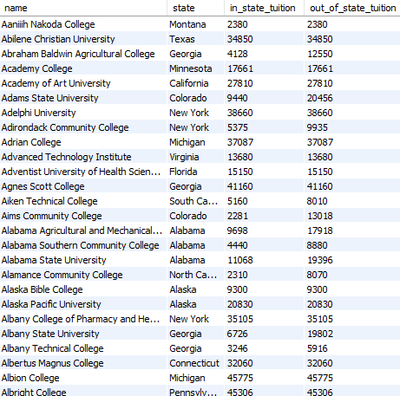

| Results:   * 2973 rows |
| --- |

2. Colleges and their Diversity Statistics

Insight: Identifies colleges with high or low minority enrollment rates.

| SELECT c.name, d.total_enrollment, d.total_minority  FROM colleges c  JOIN diversity_stats d ON c.college_id = d.college_id; |
| --- |

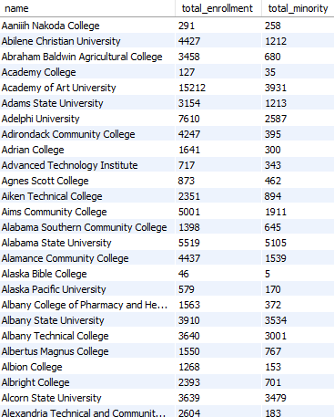

| Results:   * 2154 rows |
| --- |

3. Colleges and Salary Potential

Insight: Highlights colleges offering strong career earnings potential.

| SELECT c.name, s.early_career_pay, s.mid_career_pay  FROM colleges c  JOIN salary_potential s ON c.college_id = s.college_id; |
| --- |

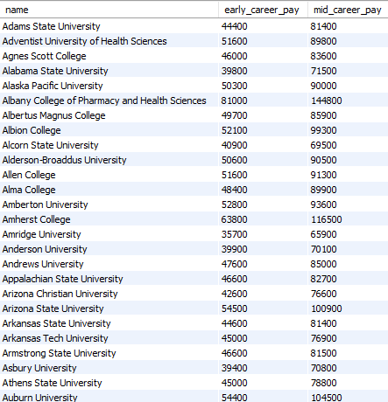

| Results:   * 899 rows |
| --- |

**Query Type: Joins across multiple tables, Aggregations (ordering)**

4. Highest Mid-Career Salaries

Insight: Find top 10 colleges producing high-earning alumni later in their careers.

| SELECT c.name, s.mid_career_pay  FROM colleges c  JOIN salary_potential s ON c.college_id = s.college_id  ORDER BY s.mid_career_pay DESC  LIMIT 10; |
| --- |

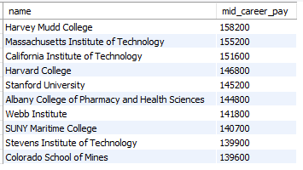

| Results:   * 10 rows |
| --- |

15. Colleges with Largest Pay Growth (Mid vs Early Career)

Insight: Where your long-term income grows the most after graduating.

| SELECT c.name, (s.mid_career_pay - s.early_career_pay) AS pay_growth  FROM colleges c  JOIN salary_potential s ON c.college_id = s.college_id  ORDER BY pay_growth DESC  LIMIT 10; |
| --- |

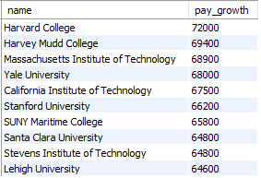

| Results:   * 10 rows |
| --- |

**Query Type: View creation for simplified analysis**

5. Create a View: College Summary

Note: The college_summary view simplifies repeated salary and tuition analysis.

| CREATE OR REPLACE VIEW college_summary AS  SELECT  c.name,  c.state,  t.institution_type,  t.degree_length,  t.in_state_tuition,  t.out_of_state_tuition,  s.early_career_pay,  s.mid_career_pay,  s.stem_percent  FROM colleges c  JOIN tuition_info t ON c.college_id = t.college_id  JOIN salary_potential s ON c.college_id = s.college_id; |
| --- |

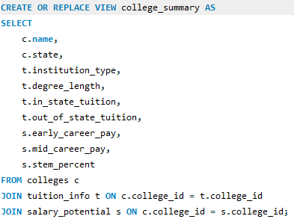

**Query Type: View usage, Aggregations (ordering)**

6. Colleges with Lowest In-State Tuition (Using View)

Insight: Lists the most affordable colleges for in-state students.

| SELECT name, state, in_state_tuition  FROM college_summary  ORDER BY in_state_tuition ASC  LIMIT 10; |
| --- |

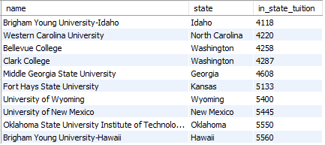

| Results:   * 10 rows |
| --- |

7. Colleges with Highest Early Career Pay (Using View)

Insight: Highlights colleges providing the best starting salaries.

| SELECT name, early_career_pay  FROM college_summary  ORDER BY early_career_pay DESC  LIMIT 10; |
| --- |

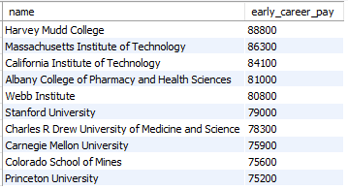

| Results:   * 10 rows |
| --- |

8. Colleges with Highest STEM Graduate Percentage (Using View)

Insight: Find colleges specializing in STEM fields.

| SELECT name, stem_percent  FROM college_summary  ORDER BY stem_percent DESC  LIMIT 10; |
| --- |

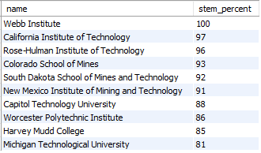

| Results:   * 10 rows |
| --- |

**Query Type: View usage, Aggregations (filtering and ordering)**

9. 2-Year Colleges with High Mid-Career Earnings (Using View)

Insight: Identifies strong career payoff for shorter degree programs.

| SELECT name, mid_career_pay  FROM college_summary  WHERE degree_length = '2 Years'  ORDER BY mid_career_pay DESC  LIMIT 10; |
| --- |

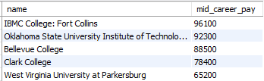

| Results:   * 5 rows |
| --- |

**Query Type: Joins across multiple tables, Aggregations (grouping, ordering)**

10. Average Tuition by State

Insight: Understands tuition differences across states.

| SELECT c.state,  AVG(t.in_state_tuition) AS avg_in_state,  AVG(t.out_of_state_tuition) AS avg_out_state  FROM colleges c  JOIN tuition_info t ON c.college_id = t.college_id  GROUP BY c.state  ORDER BY avg_out_state DESC; |
| --- |

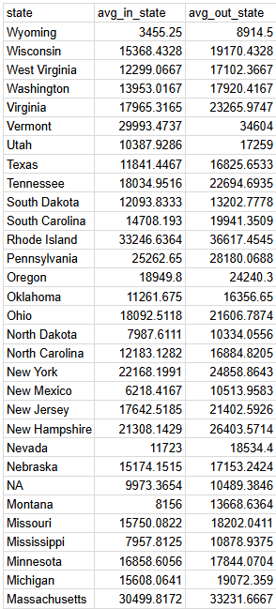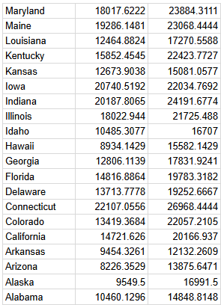

| Results:   * 51 rows |
| --- |

11. Average Early Career Pay by Institution Type

Insight: Compare public vs private institution career outcomes.

| SELECT t.institution_type, AVG(s.early_career_pay) AS avg_early_pay  FROM tuition_info t  JOIN salary_potential s ON t.college_id = s.college_id  GROUP BY t.institution_type  ORDER BY avg_early_pay DESC; |
| --- |

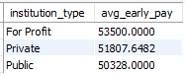

| Results:   * 3 rows |
| --- |

12. States with Highest Average Minority Enrollment

Insight: Identify states supporting diverse college environments.

| SELECT c.state, AVG(d.total_minority) AS avg_minority_percent  FROM colleges c  JOIN diversity_stats d ON c.college_id = d.college_id  GROUP BY c.state  ORDER BY avg_minority_percent DESC  LIMIT 5; |
| --- |

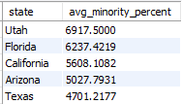

| Results:   * 5 rows |
| --- |

**Query Type: Joins across multiple tables, Subquery**

13. Colleges with Above-Average Early Career Pay

Insight: Focus on schools that beat the national early career average.

| SELECT c.name, s.early_career_pay  FROM colleges c  JOIN salary_potential s ON c.college_id = s.college_id  WHERE s.early_career_pay > (SELECT AVG(early_career_pay) FROM salary_potential); |
| --- |

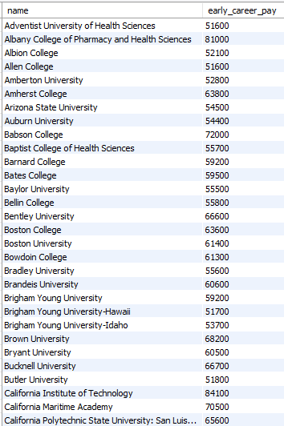

| Results:   * 388 rows |
| --- |

14. Colleges with Above-Average Minority Enrollment

Insight: Highlights colleges excelling in minority student representation.

| SELECT c.name, d.total_minority  FROM colleges c  JOIN diversity_stats d ON c.college_id = d.college_id  WHERE d.total_minority > (SELECT AVG(total_minority) FROM diversity_stats); |
| --- |

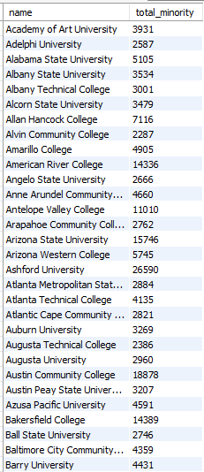

| Results:   * 573 rows |
| --- |

**Query Type: Joins across multiple tables, Aggregations (filtering, ordering)**

16. Public Colleges with Highest Diversity

Insight: Best public colleges for diversity.

| SELECT c.name, d.total_minority  FROM colleges c  JOIN tuition_info t ON c.college_id = t.college_id  JOIN diversity_stats d ON c.college_id = d.college_id  WHERE t.institution_type LIKE '%Public%'  ORDER BY d.total_minority DESC  LIMIT 10; |
| --- |

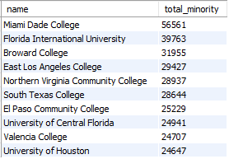

| Results:   * 10 rows |
| --- |

17. Private Colleges with Lowest Total Cost

Insight: Affordable private institutions.

| SELECT c.name, t.in_state_total  FROM colleges c  JOIN tuition_info t ON c.college_id = t.college_id  WHERE t.institution_type LIKE '%Private%'  ORDER BY t.in_state_total ASC  LIMIT 10; |
| --- |

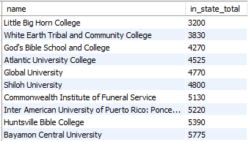

| Results:   * 10 rows |
| --- |

**Query Type: Joins across multiple tables, Aggregations (filtering)**

18. Colleges Where Women Enrollment is Below 50%

Insight: Gender imbalance insight.

| SELECT c.name, d.women  FROM colleges c  JOIN diversity_stats d ON c.college_id = d.college_id  WHERE d.women < 50; |
| --- |

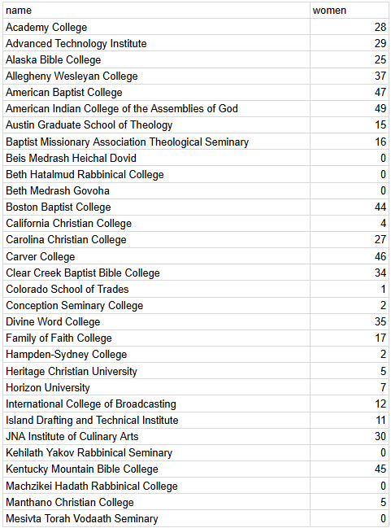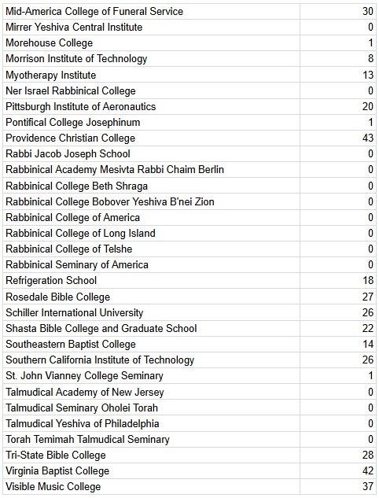

| Results:   * 74 rows |
| --- |

**Query Type: Joins across multiple tables, Aggregations (filtering, aggregation)**

19. Large Colleges (20,000+ Enrollment) and Average Mid-Career Pay

Insight: See if bigger colleges correlate with higher mid-career earnings.

| SELECT AVG(s.mid_career_pay) AS avg_mid_pay_large_colleges  FROM colleges c  JOIN salary_potential s ON c.college_id = s.college_id  JOIN diversity_stats d ON c.college_id = d.college_id  WHERE d.total_enrollment > 20000; |
| --- |



| Results:   * 1 row |
| --- |

**Query Type: Joins across multiple tables, Subquery, Aggregations (ordering)**

20. Colleges with Tuition Lower Than State Average

Insight: Colleges that are cheaper than their state’s average cost for their institution type.

| SELECT c.name, c.state, t.in_state_tuition  FROM colleges c  JOIN tuition_info t ON c.college_id = t.college_id  WHERE t.in_state_tuition < (  SELECT AVG(t2.in_state_tuition)  FROM tuition_info t2  WHERE t2.institution_type = t.institution_type  )  ORDER BY c.state; |
| --- |

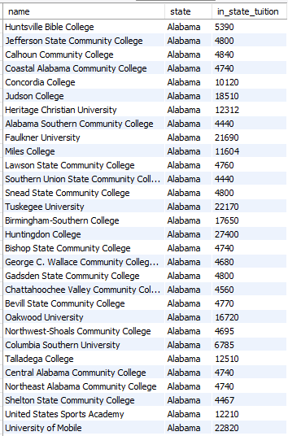

| Results:   * 1678 rows |
| --- |